Short term plan

Unit 5: Our health |  | School: №176 school-gymnasium
Date: - |  | Teacher name: Adaskhanova Zhaina
Grade: 6 |  | Number present: 10 | Absent:-
Lesson theme |  | Home remedies
Learning objectives |  | 6.4.4.1 (6.R4) read independently a limited range of short simple fiction and non -fiction texts  6.3.3.1 (6.S3) give an opinion at sentence and discourse level on an increasing range of general and curricular topics
Lesson objectives |  | - Read short simple non-fiction text to identify the specific and general information  - Provide a point of view on the topic in conversations and discussions
Stages / Time | Teachers actions |  |  | Students actions | Assessment | Resources
Greetings  2 mins | Teacher greets learners:  - Good morning!  - How are you?  - What date is it today? |  |  | Learners respond
Warm-up activity  5 mins  Total  Physical  Response | Teacher shows the video to watch “5 Minute warm up exercises” song and do!  from 00/00 to 04/25 min |  |  | Learners watch the video and do action. | Descriptor:  A learner: watches a video, follows the instruction and repeats the action | https://www.youtube.com/watch?v=H1zuAsoGpl4
Brainstorming  3 mins  Scaffolding  Tap into prior knowledge | The teacher shows learners pictures of Home remedies  - What can you see?  - What can we do with them?  - What other countries home remedies do you know?  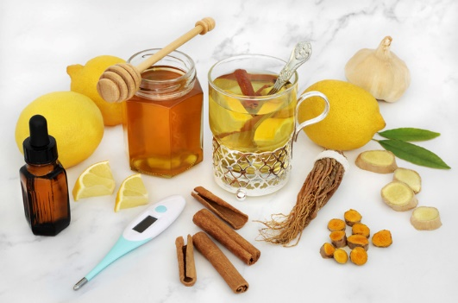 |  |  | Learners answer the questions.  Answering the questions, they will guess what a text they are going to read may be about. | Verbal assessment (teacher assessment)  «The praise» method is used to evaluate Ss with phrases like:  “Good job!  Well done!  Excellent!”  Descriptor  Learners look at the pictures and answer the questions. Try to guess the name of today's title and say | https://www.flushinghospital.org/newsletter/home-remedies-for-a-cold-and-the-flu/
Pre-reading  5 mins  Pre-teach  Scaffolding  Visual aids | Teacher shows new vocabulary from PPT and explains the meaning through definitions  New words Definition  remedy (n) something that makes you better when you are sick  ingredient (n) one of the different foods that a particular type of food is made from  treat (v) to give medical care to someone for an illness or injury  get rid of (ph.v) to end something unpleasant  nasty (adj.) very bad  awful (adj.) very bad , of low quality , or unpleasant  extract (n) a substance taken from a plant , flower , etc and used especially in food or medicine  relief (n) an end to or pause in a feeling of pain  taste (n) the flavour of a particular food in your mouth  cough syryp (n) a thick liquid that you take to help stop coughing |  |  | Learners listen and repeat new words after teacher | Verbal assessment  Concept checking questions  If you cough what medicine do you drink? – syryp  Assessment criteria  Explain the meaning of new words | Handouts1
While-reading  6 mins | Teacher shows the text and asks to read the title: |  |  | Learners look at the pictures and read the text. What remedies might someone find at home?  Differentiation by task and resource  Low-motivated ss -Complete the table.  High-motivated ss – research and add other remedies  (use the additional resource) | Assessment  Criteria  Read short simple non-fiction text to identify the general and specific information  headache  stomachache  cough  sore throat  toothache | Excel 6 sb p54  Go to the following link:  https://www.youtube.com/watch?v=EjIPqbQJP4I
Comrehension questions  Differentiation by task  5 mins | Task 1. – Group 1 Read the text and answer the questions  1. What happens if you drink lemon during a headache?  2. What to drink lemon juice with?  3. When should you drink ginger tea?  4. What ingredient is in chocolate?  5. Which ingredient helps with sore throat? |  |  | Learners read the text and find specific information | Criteria assessment  Descriptor  Assessment criteria Task Descriptor Mark  A leaner writes  Read short simple fiction and non-fiction texta to identify the general information Learners read the text and answer the questions it is refreshing and relaxing 1  warm water 1  a stomach ache 1  a cough syrup 1  Natural and tasty honey 1 | Handouts 2
 | Task 2. Write True (T) or False (F) sentences. Correct the false ones.  1. Lemon - a great ingredient to treat headaches  2. Natural honey help sore throats. Add one teaspoon to a glass of hot water and drink quickly.  3. Chocolate can stop a nasty cough  4.Apply some vanilla extract on your teeth to get rid of toothache fast.  5.Drink some lemon juice with hot water to help get rid of that nasty pain. |  |  | Learners look through the text and choose the correct statements true or false from the game. | Criteria assessment  Descriptor  Assessment criteria Task Descriptor Mark  A leaner writes  Read short simple fiction and non-fiction texta to identify the general information Ss reads the text again and marks sentences True or False T 1  F (drink slowly) 1  T 1  T 1  F (warm water) 1 | Handouts3
Post-reading  5 mins | Teacher suggests new words with the learning apps.  Match the words with their definitions. |  |  | High learners write and complete definitions with the suitable words. | Self assessment  Descriptor  Assessment criteria Task Descriptor Mark  A leaner writes  Read short simple fiction and non-fiction texta to identify the general information High motivated learners writes and completes definitions with the suitable words. extract (n) - a substance taken from a plant , flower , etc and used especially in food or medicine 1  cough syryp (n) - a thick liquid that you take to help stop coughing 1  treat (v)- to give medical care to someone for an illness or injury 1  remedy (n)- something that makes you better when you are sick 1  get rid of (ph.v)- to end something unpleasant 1 | https://learningapps.org/create?new=71#preview
 | Teacher suggests new words with the learning apps  Match the words with their pictures |  |  | Low motivated learners write and match the new words with pictures | Self assessment  Descriptor  Assessment criteria Task Descriptor Mark  A leaner writes  Read short simple fiction and non-fiction texta to identify the general information Low motivated Ss writes and matches the new words with their meanings 1  1  1  1  1 | https://learningapps.org/display?v=pgwuohm2v22
Speaking  10 mins  Pair work | Teacher asks what they understand from the text  Teacher give time to talk  (Scaffolding S)  1. You can treat folk remedies at home. Do you agree or disagree?  2. How often do you use folk remedies at home?  3. What folk remedies can be used to treat headaches at home? |  |  | Learners same a rise discuss what they remember and answer  Useful expressions  I think  I absolutely agree  I totally against  I am not sure that | Open class feedback  -Provide a point of view on the topic in discussions | Handouts4
Ending  2 mins  Home work | Teacher says to repeat today's new words and for writing ex 4 |  |  | Learners write down the tasks in a notebook | Individual work | Handouts5
Feedback  2 mins | Teacher gives learners traffic lights. Learners give feedback to the lesson. How many understood today's lesson?  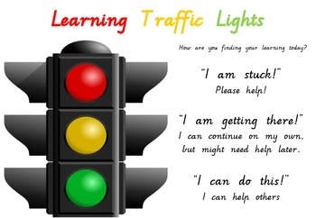 |  |  | Learners give feedback (traffic lights) | Individual work | https://www.teacherspayteachers.com/Product/Reflection-Traffic-Light-Keyring-Assessment-1215401

